ABC’s Inventory Management System

Manage Product (Update Stored Product) Test Scripts

Table of Contents

USPT001- Update the quantity of a Product Item in a Location by entering accurate quantity value 3

Data Set 1 3

Result Screenshots: 3

USPT002- Update the quantity of a Product Item in a Location by entering an invalid quantity value. 8

Result Screenshots: 8

Data Set 1 8

Data Set 2 12

Result Screenshots: 12

# USPT001- Update the quantity of a Product Item in a Location by entering accurate quantity value

|  |  |  |  |  |  |
| --- | --- | --- | --- | --- | --- |
| **Test Name** | | Test update the quantity of a Product Item in a Location by entering accurate quantity value (Test USPT001) | | | |
| **Use Case Tested** | | Manage Product | | | |
| **Test Description** | | This test tests if the system can update the quantity of a product item in a location. | | | |
| **Pre-Conditions** | | Users need be logged in as a Warehouse Staff (Warehouse Staff Access) in the Manage Product page  Meta data to store Product Item details in the database must exist. | | | |
| **Post-Conditions** | | Quantity of the product item in the selected location must be updated. | | | |
| **Result (Pass/Fail/Warning/ Incomplete)** | | Pass | | | |
|  | **Test Step** | | **Expected Test Results** | **P** | **F** |
| 1. | Click on ‘Detail’ icon for the product whose quantity of a product item in a location needs to be updated. | | Different product item that exist for the product is displayed. | P |  |
| 2. | Click on ‘Detail’ icon for the product item whose quantity in a location needs to be updated. | | Different location where the product item exists along with details like quantity is displayed. Quantity is the only value which is editable. | P |  |
| 3. | Double click on quantity of the product item in the location where it needs to be updated. | | Highlights the quantity and waits for user to edit the quantity. | P |  |
| 4. | Enter the quantity that needs to be changed and hits enter. | | Changes the quantity in the table and waits for user to click on ‘Confirm’ icon to update it in the database. | P |  |
| 5. | Click on ‘Confirm’ icon. | | Update the quantity in the database and display an appropriate message. | P |  |

## Data Set 1

|  |  |
| --- | --- |
| **Data Set 1** | |
| **Fields** | **Values** |
| **Product Code** | L2 |
| **Product Size (Product Item)** | XS (L2100) |
| **Location** | STR1 |
| **Old Quantity** | 5 |
| **New Quantity** | 8 |

### Result Screenshots:

**Step 1**

Manage Product Page where the ‘Detail’ icon of the Product whose quantity of product item in a particular location needs to be changed is clicked.

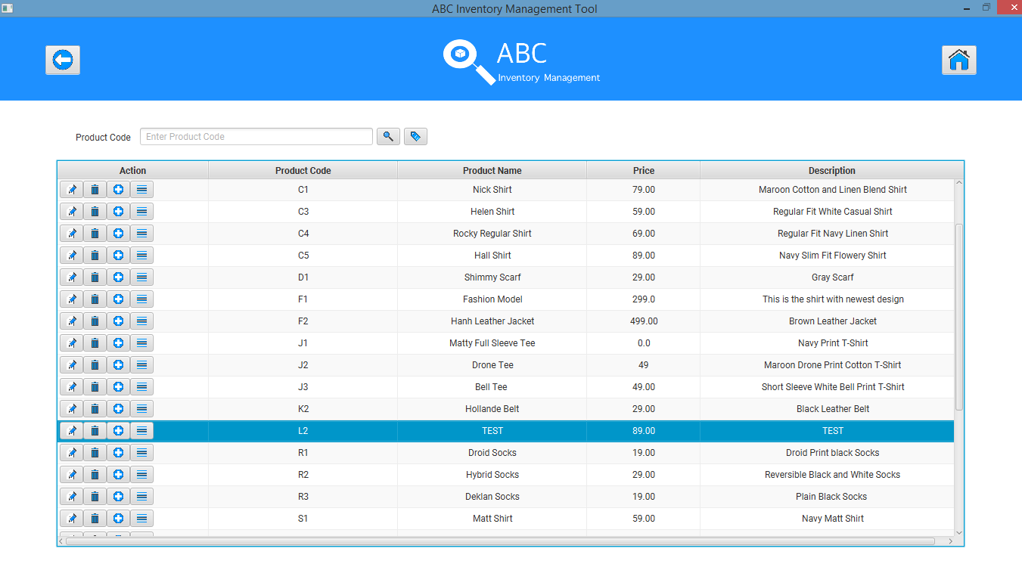

Various product item that exists for the selected product is displayed.

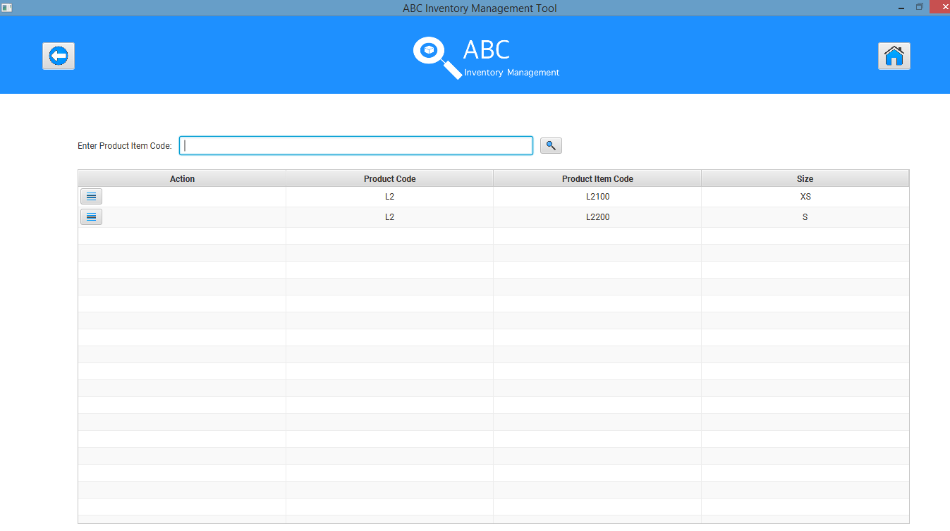

**Step 2**

After user clicks on the ‘Detail’ icon for the required product item, various location that have the selected product item is displayed.

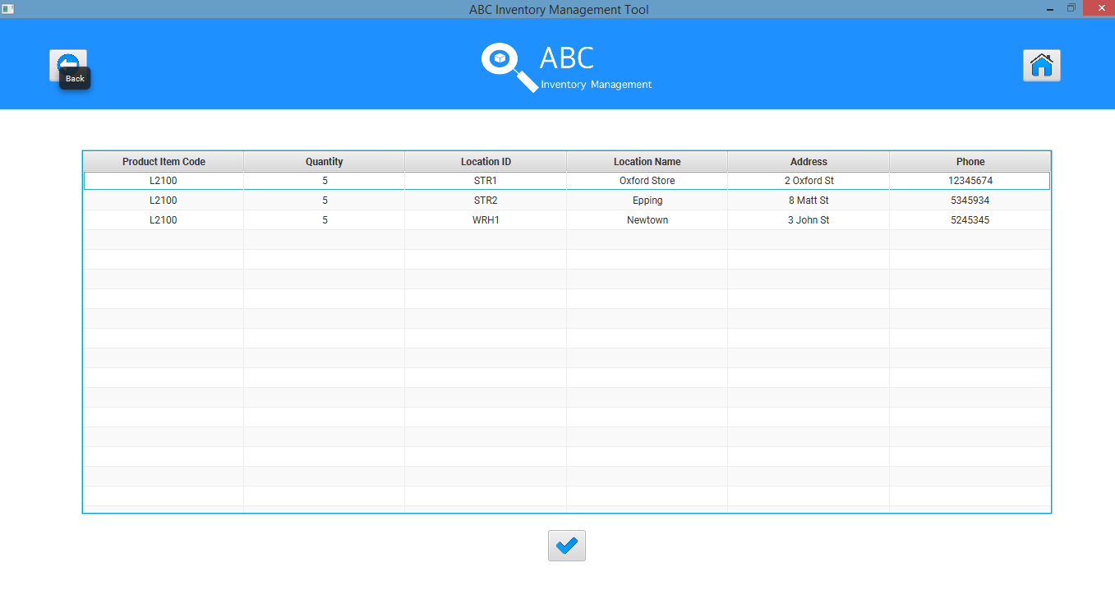

**Step 3**

Double clicking the quantity to change it.

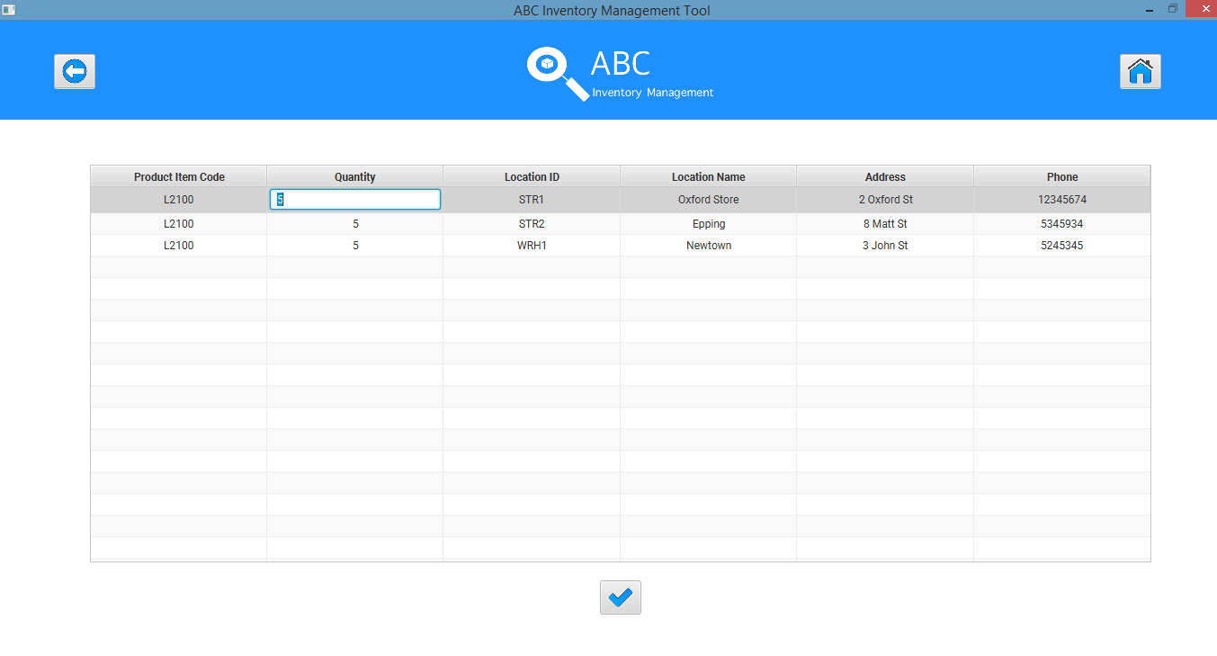

**Step 4**

Changing the quantity from 5 to 8.

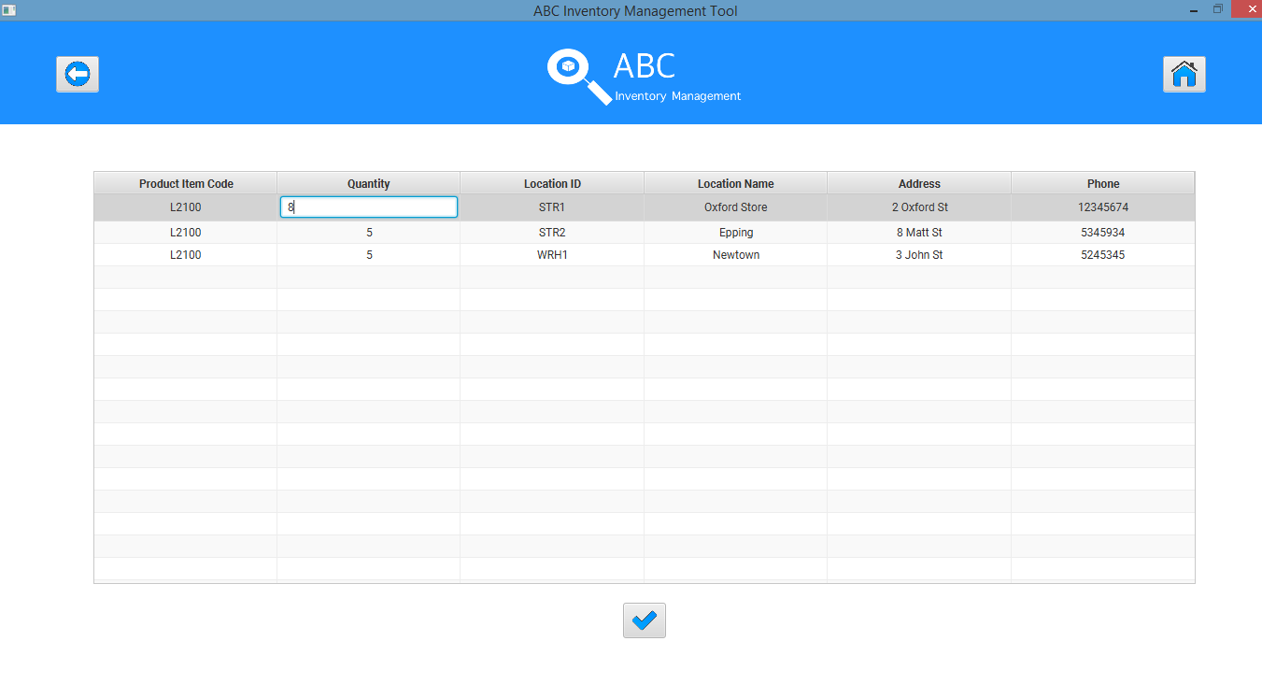

Hitting the enter button.

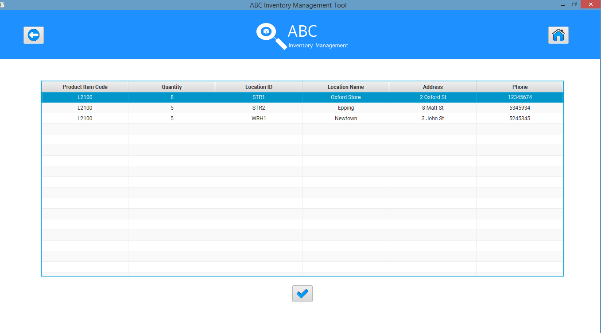

**Step 5**

After clicking on the ‘Confirm’ icon.

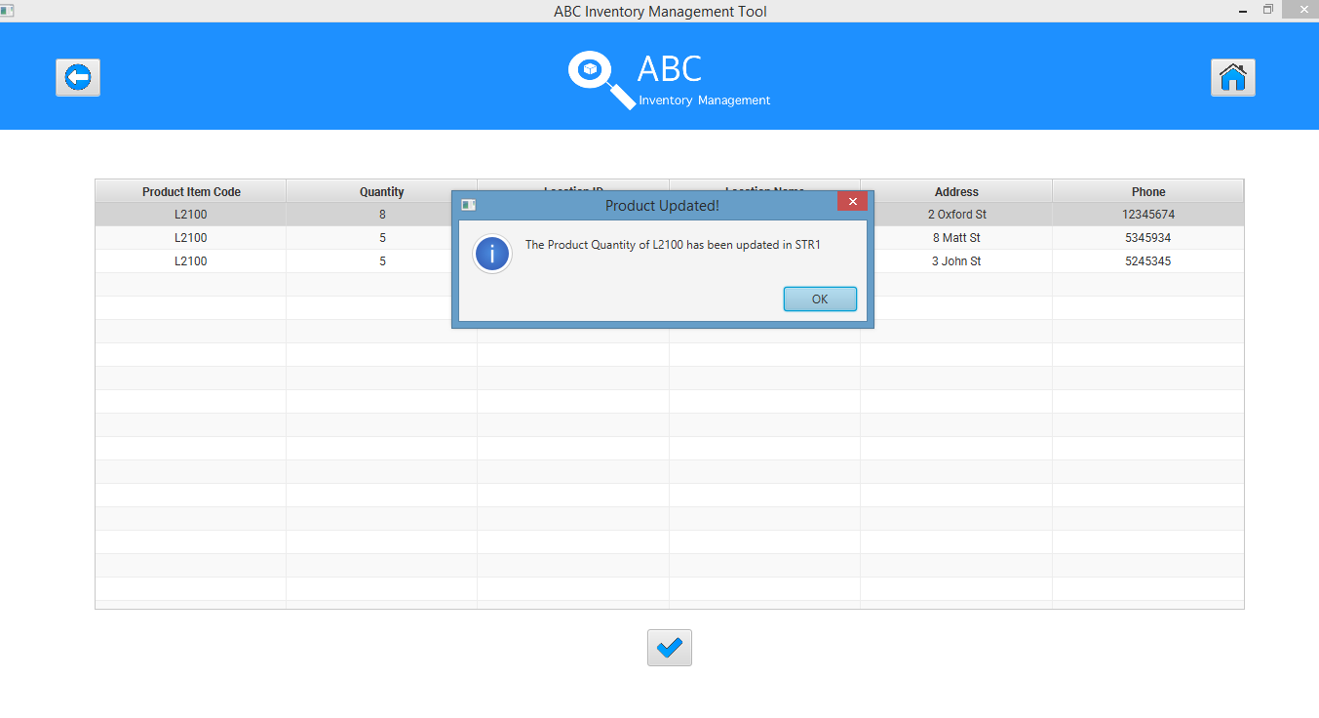

After clicking on ‘OK’, the manage product page is displayed.

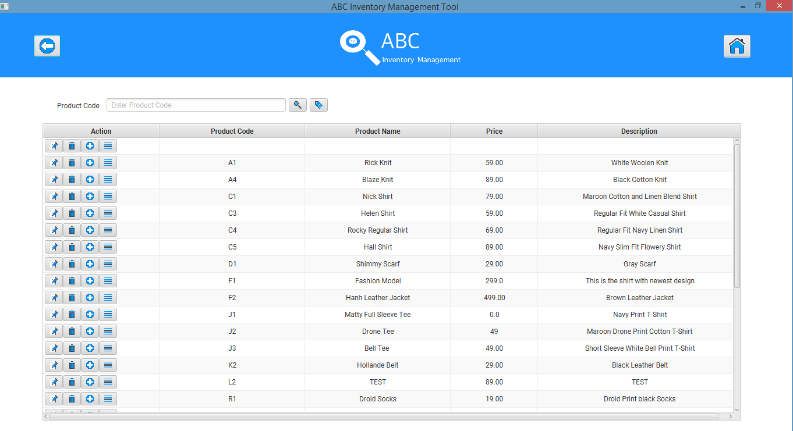

# USPT002- Update the quantity of a Product Item in a Location by entering an invalid quantity value.

|  |  |  |  |  |  |
| --- | --- | --- | --- | --- | --- |
| **Test Name** | | Test update the quantity of a Product Item in a Location by entering an invalid quantity value (Test USPT001) | | | |
| **Use Case Tested** | | Manage Product | | | |
| **Test Description** | | This test tests how the system reacts when an invalid quantity value is entered while updating the quantity. | | | |
| **Pre-Conditions** | | Users need be logged in as a Warehouse Staff (Warehouse Staff Access) in the Manage Product page  Meta data to store Product Item details in the database must exist. | | | |
| **Post-Conditions** | | Appropriate error message is displayed. | | | |
| **Result (Pass/Fail/Warning/ Incomplete)** | | Pass | | | |
|  | **Test Step** | | **Expected Test Results** | **P** | **F** |
| 1. | Enter an invalid quantity while updating the stored product after following steps 1 and 2 in USPT001 and hit enter. | | System waits for the user to click on the ‘Confirm update’ icon. | P |  |
| 2. | Click on the ‘Confirm’ icon. | | System displays an appropriate error message does not update the quantity. Users can repeat step 1 until a valid quantity is entered. | P |  |

### Result Screenshots:

## Data Set 1

|  |  |
| --- | --- |
| **Data Set 1** | |
| **Fields** | **Values** |
| **Product Code** | L2 |
| **Product Size (Product Item)** | XS (L2100) |
| **Location** | STR2 |
| **Old Quantity** | 5 |
| **New Quantity** | ABC (Non-numeral value) |

**Step 1**

Different quantities in different stores for a particular product item.

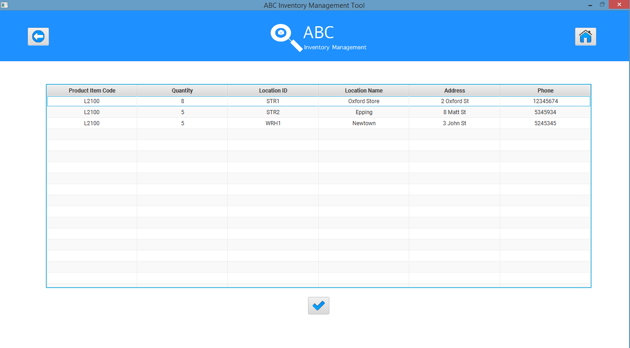

Double clicking on the quantity in a store that needs to be changed.

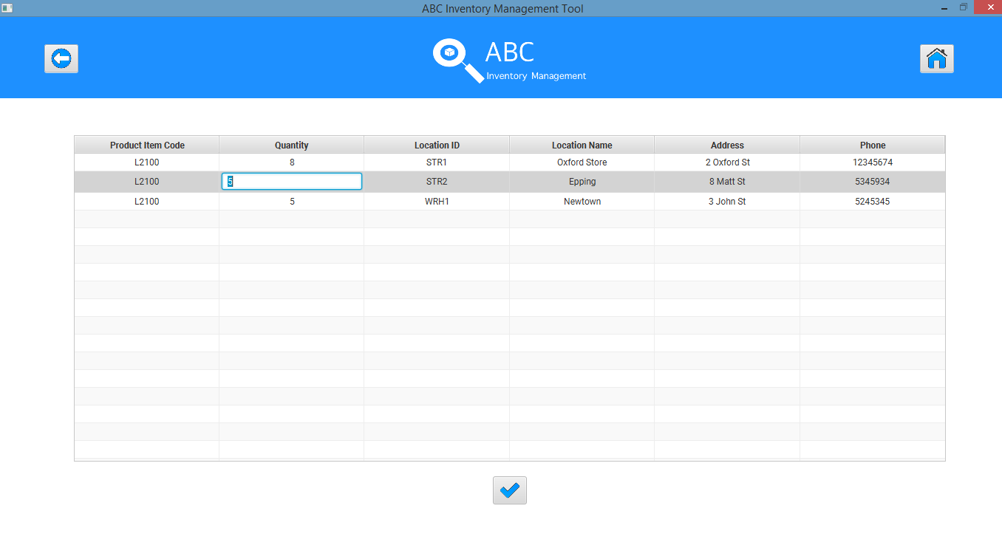

Entering a non-numeral quantity.

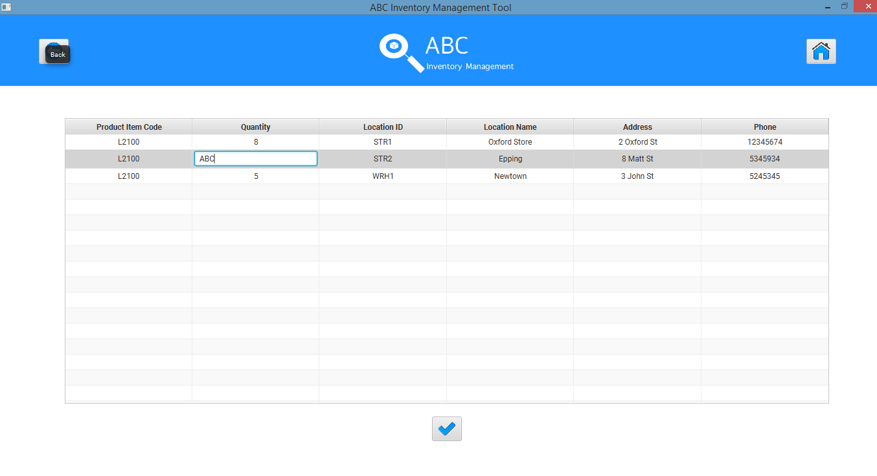

Hitting enter.

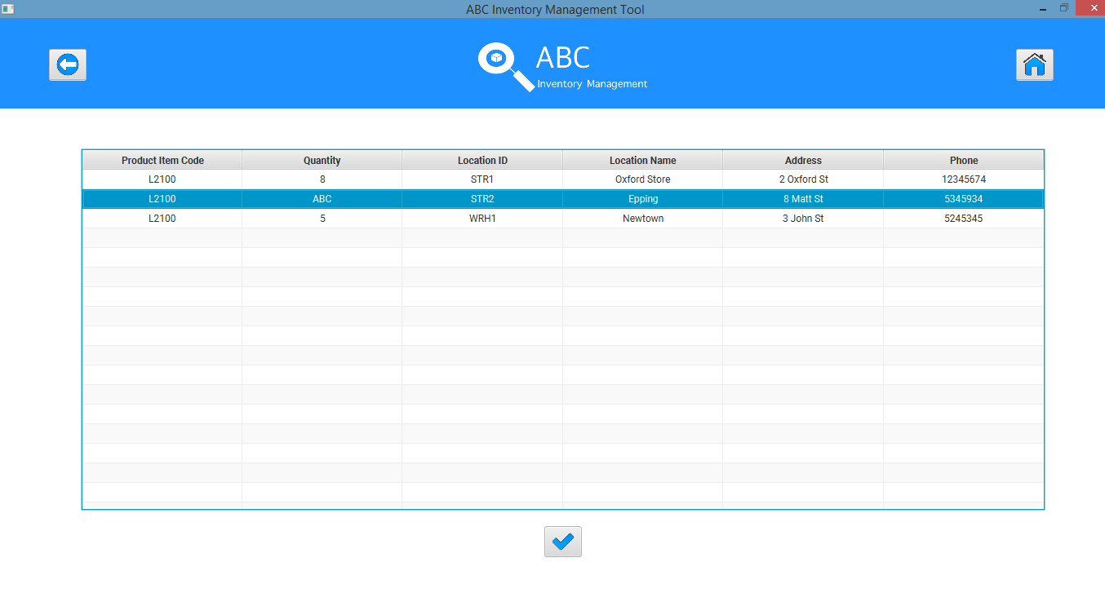

**Step 2**

After clicking on the ‘Confirm’ Icon the system displays an appropriate error message.

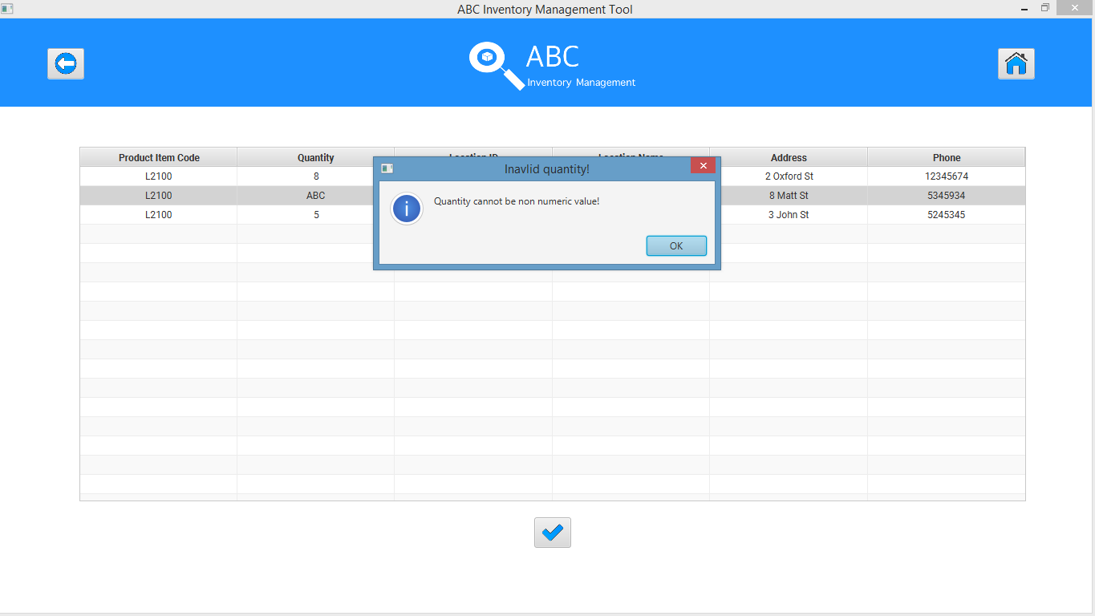

Users can repeat step 1 and 2 to try to change the quantity again using a valid quantity value.

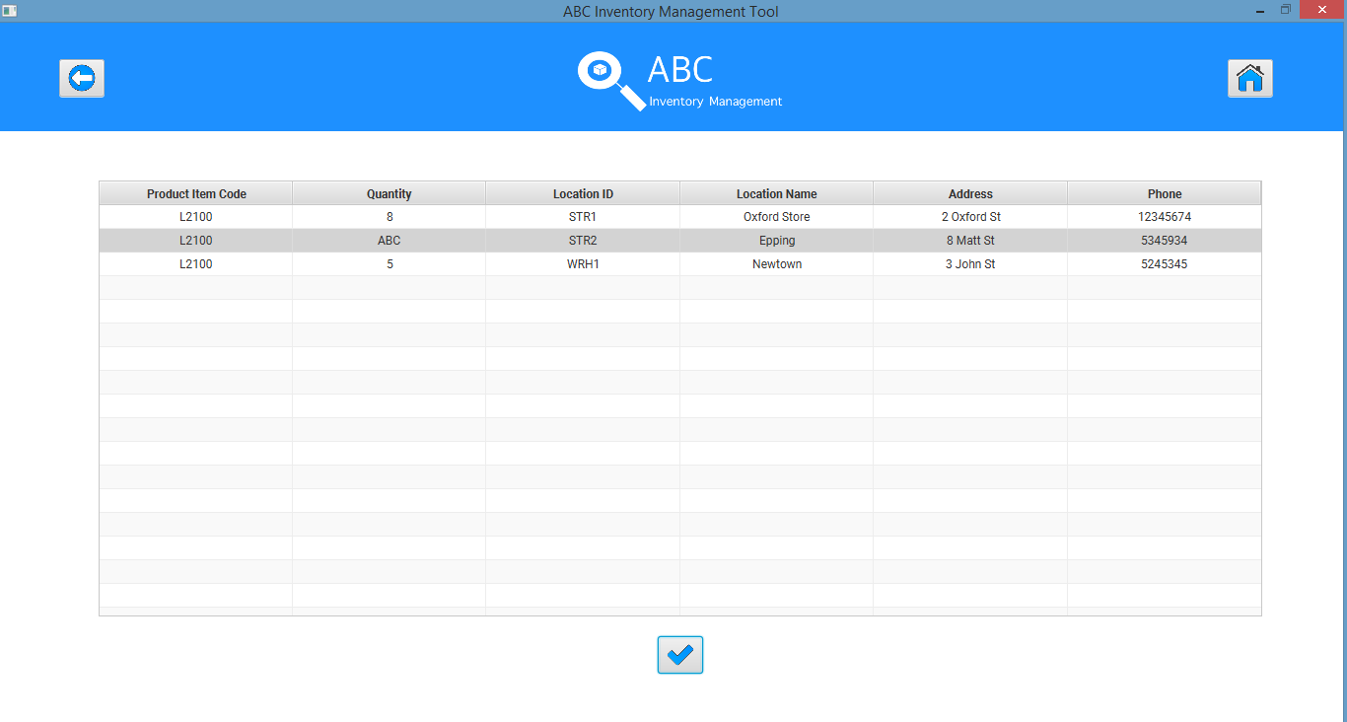

## Data Set 2

|  |  |
| --- | --- |
| **Data Set 2** | |
| **Fields** | **Values** |
| **Product Code** | L2 |
| **Product Size (Product Item)** | XS (L2100) |
| **Location** | STR2 |
| **Old Quantity** | 5 |
| **New Quantity** | -10 (Negative value) |

### Result Screenshots:

**Step 1**

Different quantities in different stores for a particular product item.



Double clicking on the quantity in a store that needs to be changed.



Entering a negative quantity value.

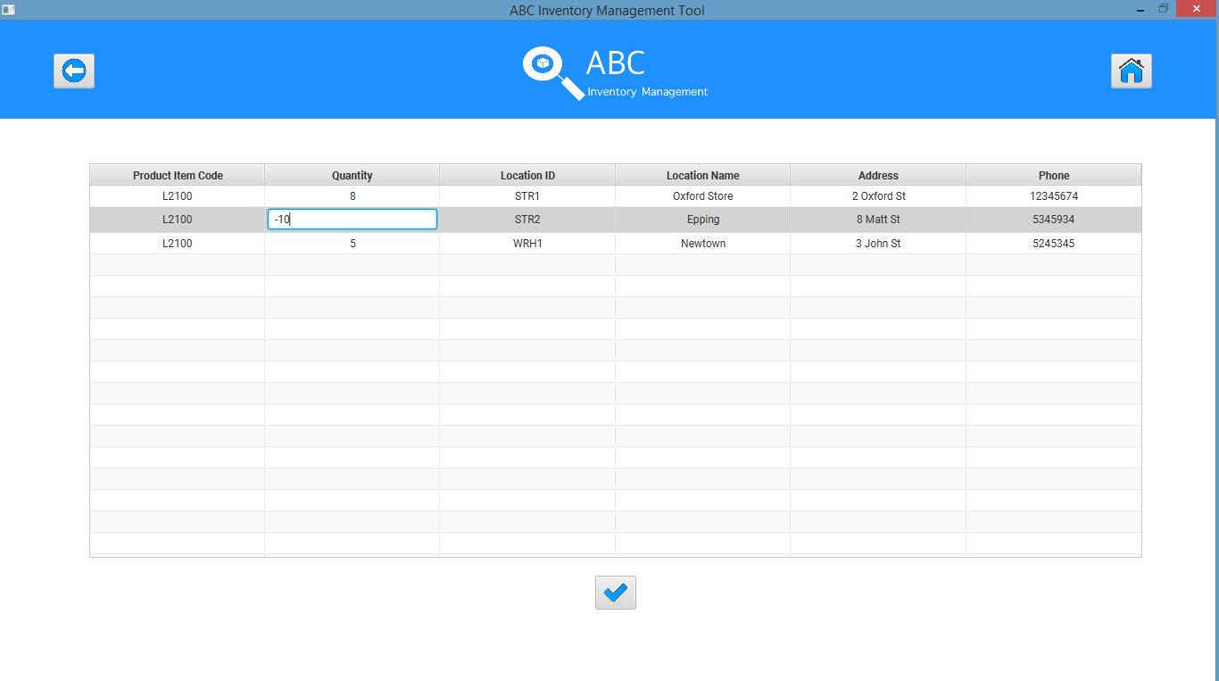

Hitting enter.

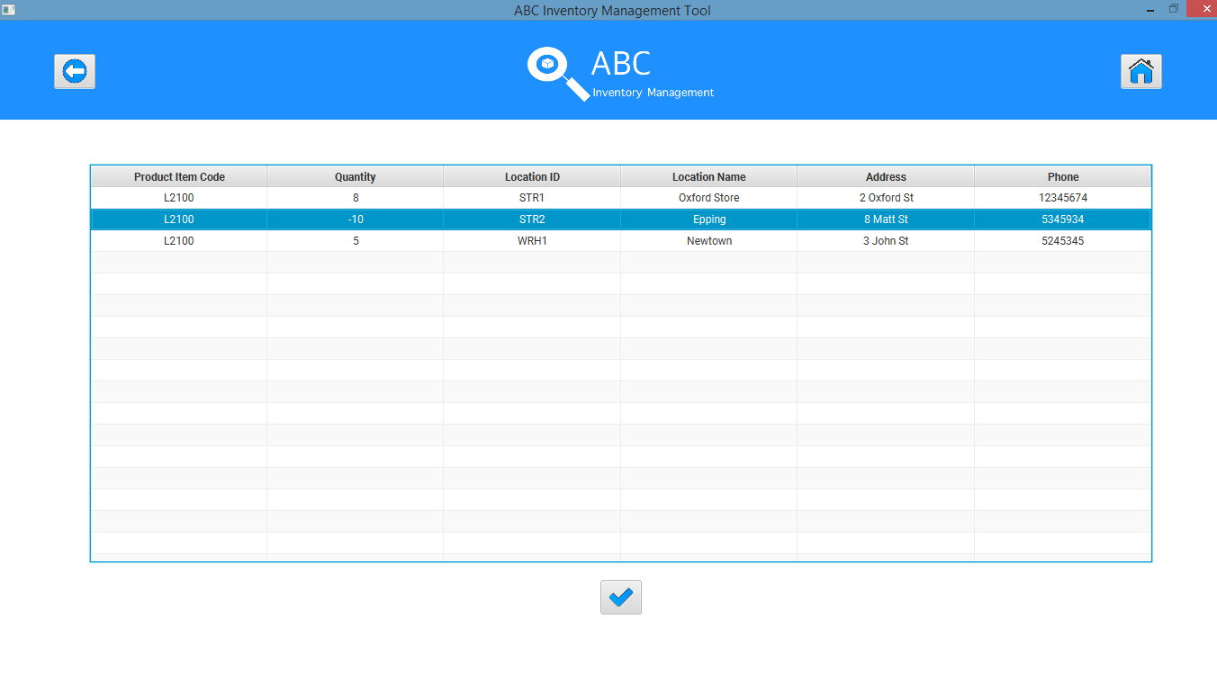

**Step 2**

After clicking on the ‘Confirm’ Icon the system displays an appropriate error message.

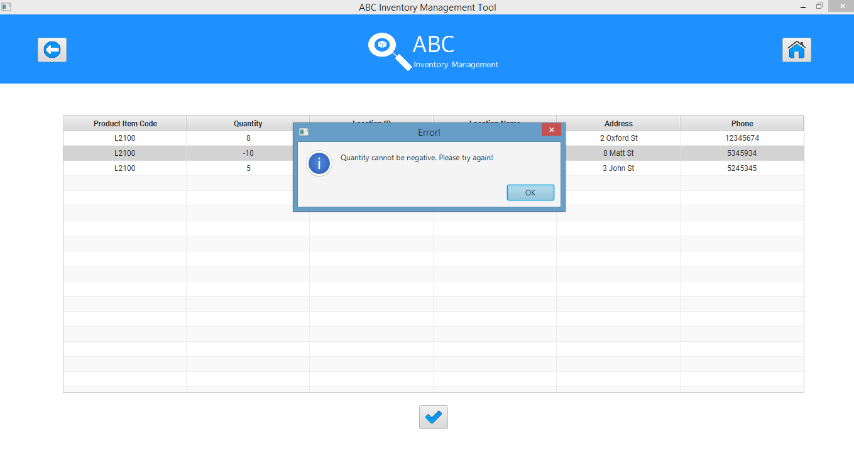

Users can repeat step 1 and 2 to try to change the quantity again using a valid quantity value.

